Project Design Phase-II
Data Flow Diagram & User Stories

Date | 9 March 2025
Team Members | Mansi,Om,Meenakshi,Nitesh-
Project Name | Plugging into the Future: An exploration of electricity
Maximum Marks | 4 Marks

Data Flow Diagrams:
A Data Flow Diagram (DFD) is a traditional visual representation of the information flows within a system. A neat and clear DFD can depict the right amount of the system requirement graphically. It shows how data enters and leaves the system, what changes the information, and where data is stored.
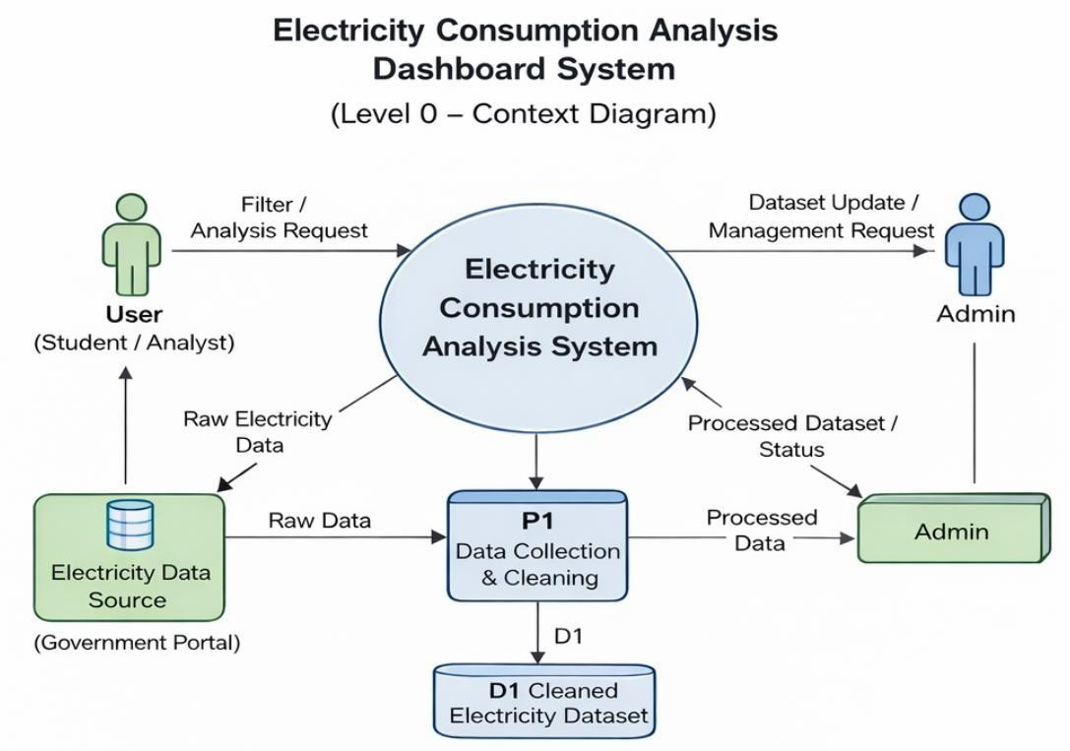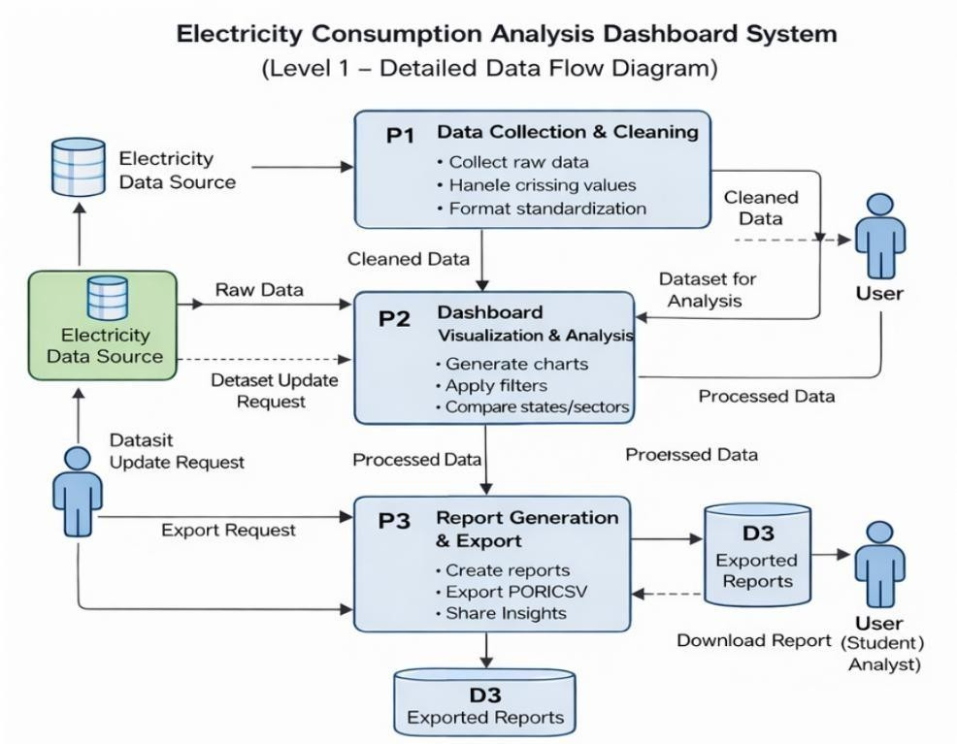
User Stories
User Type | Functional Requirement  (Epic) | User Story No | User Story / Task | Acceptance Criteria | Priority | Release
User  (Student/Analyst) | Dashboard | USN-1 | As a user, I can view overall electricity consumption data | Dashboard loads with visualizations | High | Sprint-1
User  (Student/Analyst) | Visualization | USN-2 | As a user, I can view state-wise electricity consumption | State-wise chart displays correctly | High | Sprint-1
User  (Student/Analyst) | Visualization | USN-3 | As a user, I can view year-wise consumption trends | Trend graph updates properly | High | Sprint-1
User  (Student/Analyst) | Visualization | USN-4 | As a user, I can view sector-wise electricity usage | Sector breakdown chart visible | High | Sprint-1
User  (Student/Analyst) | Filtering | USN-5 | As a user, I can filter data by state | Dashboard updates based on  selected state | High | Sprint-1
User  (Student/Analyst) | Filtering | USN-6 | As a user, I can filter data by year | Dashboard updates based on  selected year | High | Sprint-1
User  (Student/Analyst) | Comparison | USN-7 | As a user, I can compare electricity consumption between states | Comparison chart displays correctly | High | Sprint-1
User  (Student/Analyst) | Insights | USN-8 | As a user, I can identify high and low consumption states | System highlights consumption differences | Medium | Sprint-1
User  (Student/Analyst) | Reports | USN-9 | As a user, I can export dashboard data | Data downloads successfully in file format | Medium | Sprint-2
Administrator | Data Management | USN-10 | As an admin, I can upload new electricity datasets | Dataset uploads without errors | High | Sprint-1
Administrator | Data Management | USN-11 | As an admin, I can update existing datasets | Updated dataset reflects in dashboard | High | Sprint-1
Administrator | Data Management | USN-12 | As an admin, I can manage dataset storage | Cleaned data stored and retrievable | Medium | Sprint-2

